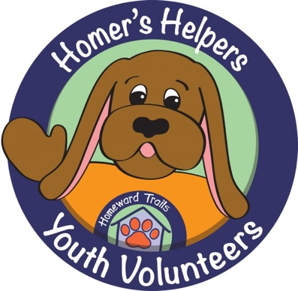

HOMEWARD TRAILS YOUTH PROGRAMS REGISTRATION FORM

Child’s Name: ___________________________________ Age:________

Parent/Guardian: __________________________________________________

Address: ________________________________________ Zip: ____________

Email: _______________________________ Phone: ____________________

Who will be picking your child up from the program? (Please list all names that apply)

Name:_________________________________ Phone:__________________

Name:_________________________________ Phone:__________________

Name:_________________________________ Phone:__________________

Where did you hear about our program? ________________________________________

Allergies:___________________________________________________________________

Any special considerations we should know about? ___________________________________

Emergency Contact Names and Phone Numbers:

__________________________________________________________________________

__________________________________________________________________________

I, (Parent/Guardian Name) ______________________________________________________, give permission for my child to participate in the activities at the Homeward Trails Adoption Center. This includes activities that involve work with animals, touching animals, and/or being around animals. I agree that the XXX shall not be responsible for any injuries or losses sustained by above named child while on camp premises, or as a result of any Homeward Trails Animal Rescue sponsored activity. I further agree to indemnify and hold harmless Homeward Trails Animal Rescue from any claims or demands arising out of any such injuries or losses.

Signature:___________________________________ Date:_____________________________

PHOTO AND VIDEO RELEASE:

I, (Parent/Guardian Name) __________________________________________________, give permission for Homeward Trails Animal Rescue staff or volunteers to take photographs or videos of my child (Name) ________________________ while participating in Homeward Trails Animal Rescue activities and programs, which may be used for Homeward Trails Animal Rescue publicity purposes. I authorize Homeward Trails Animal Rescue, its assigns and transferees to copyright, use and publish the same in print and/or electronically, including, but not limited to, organization websites and social media.

Signature:____________________________________ Date:____________________________

